TECHNICAL MATHEMATICS GRADE 12 30minutes
Instructions:
1. Work out the answer to each question and then choose the letter of the answer that corresponds to your answer.
2. You may use an approved scientific calculator (non-programmable and non-graphical), unless stated otherwise.
3. If necessary, round off answers to TWO decimal places unless stated otherwise.

EUCLIDEAN GEOMETRY
Question 1
Given: AB║EC,
Give a reason for this statement: $B\hat{C}D=73°$
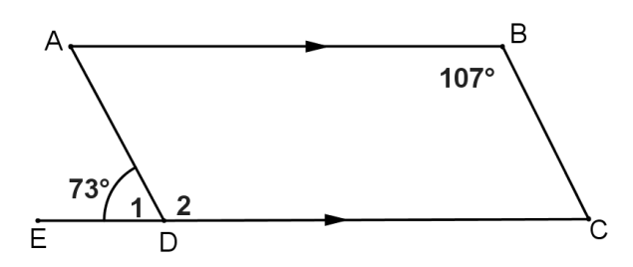

A. | (corresp ∠s; AD ║ BC)
B. | (co-int ∠s; AB ║ DC)
C. | (ext ∠ of cyclic quad)
D. | (∠s on a str line) )
Question 2
In the diagram, O is the centre of the circle passing through A, B and C.
$C\hat{A}B=48°,C\hat{O}B=x.$ Determine with reasons the size of $x.$
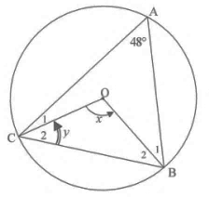
A. | $x=24°…$(∠ at centre = 2 $×$ ∠ at circumference)
B. | $x=96°…$(∠ at centre = 2 $×$ ∠ at circumference)
C. | $x=48°…$(∠s in the same seg)
D. | $x=96°…$(∠s in the same seg)

Question 3
In the given diagram, AB is a chord of a circle with centre O.
OE bisects AB. AD =12, ED = 8 cm and OD = x.
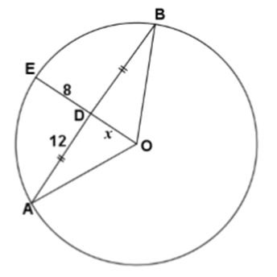
Why is $O\hat{D}A=90°?$

A. | (line from centre ⊥ to chord)
B. | (line from centre to midpt of chord)
C. | (perp bisector of chord)
D. | None of these

Question 4
In the given diagram, O is the centre of the circle and tangent FC touches the circle at C.
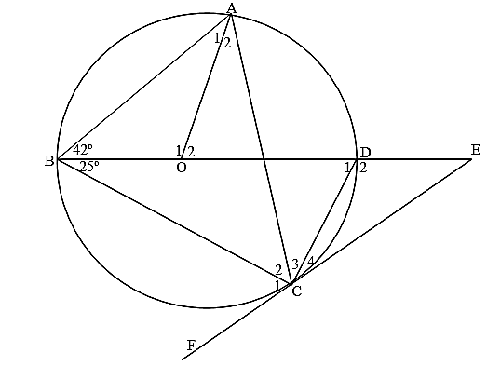
Why is $B\hat{C}D=90°$

A. | (tan chord theorem)
B. | (∠s in semi circle)
C. | (∠ at centre = 2 $×$ ∠ at circumference)
D. | (∠s opp equal sides)
Question 5
In the given diagram, O is the centre of the circle and tangent FC touches the circle at C.
Why is ${\hat{C}}_{4}=25°$?

A. | (tan chord theorem)
B. | (∠s in semi circle)
C. | (∠ at centre = 2 $×$ ∠ at circumference)
D. | (∠s opp equal sides)
COMPLEX ANGLES
Question 6
Given: $-2+5i$ is

A. | the rectangular form
B. | the polar form
C. | the argument
D. | the modulus
Question 7
Simplify:$\frac{-6+\sqrt{-144}}{3}$Write your answer in the form $a+bi$
A. | None of these
B. | $$-6+0i$$
C. | $$2-4i$$
D. | $$-2+4i$$
Question 8
Calculate the value of $θ=A\hat{O}B$ using the information in the diagram below:
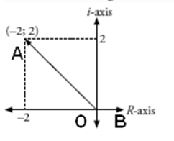

A. | $θ=A\hat{O}B=45°$
B. | $$θ=A\hat{O}B=225°$$
C. | $θ=A\hat{O}B=135°$
D. | $$θ=A\hat{O}B=-45°$$
Question 9
Solve for $x$ and $y$
$3x-1+2yi+3i=6-7i$
Which of these is the correct next step?

A. | $3x+2yi=5-10i$
B. | $3x+2yi=5-4i$
C. | $\left(3x-1\right)+\left(2y+3\right)i=6-7i$
D. | None of these

Question 10
Calculate the value of $θ=A\hat{O}B$ using the information in the diagram below:

A. | $θ=A\hat{O}B=45°$
B. | $$θ=A\hat{O}B=225°$$
C. | $θ=A\hat{O}B=135°$
D. | $$θ=A\hat{O}B=-45°$$
CIRCLES, ANGLES AND ANGULAR MOVEMENT
Question 11
Which is the correct formula to calculate the circumference of a circle?

A. | $$2πr$$
B. | $$πr^{2}$$
C. | $$\frac{πd^{2}}{4}$$
D. | $$2r$$
Question 12
Convert $35°$ to radians

A. | $\frac{7}{36π}$ radians
B. | $\frac{7}{36}π$ radians
C. | None of these
D. | $\frac{7π}{36}$
Question 13
A circle has an area of $160π$ cm². What is the diameter of the circle?

A. | 25,29
B. | 25,3 cm
C. | 12,64
D. | 12,65 cm

Question 14
The area of the sector of a circle is 2,5 m² and the radius of the circle is 1,8 m. Calculate the angle in the sector at the centre of the circle in radians.
Area of sector = $\frac{1}{2}r^{2}θ$

A. | $\frac{125}{81}$ radians
B. | $\frac{125}{34}$ radians
C. | $\frac{81}{20}$ radians
D. | None of these
Question 15
Which of one these statements or formulae apply to angular velocity?

A. | $v$ = $πDn$
B. | measures the velocity along the edge of a turning wheel or disc.
C. | measures the velocity at the centre of a turning wheel or disc.
D. | $v=ωr$

SOLUTIONS TO TECH MATHS PRE POST TEST

QUESTION | ANSWER
1 | B
2 | A
3 | B
4 | B
5 | A
6 | A
7 | D
8 | C
9 | C
10 | C
11 | A
12 | B
13 | B
14 | A
15 | C

